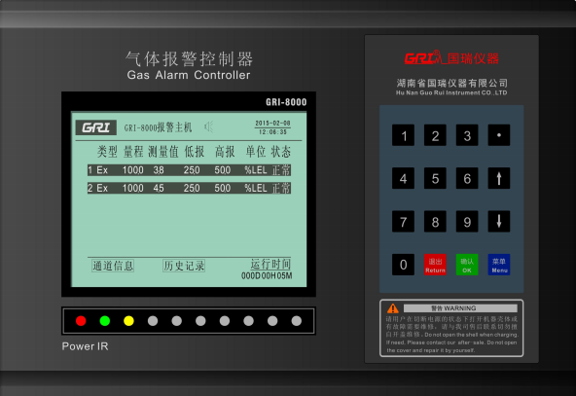
220VACCC
485AA
485B
4*1.5电缆屏蔽线
24VDC+
24VDC-
485A
485B

